**1. Name of Service**

qPCR Service

**2. Description:**

qPCR and reverse transcription qPCR (RT-qPCR) have been widely used for mRNA quantification with advanced specificity, sensitivity and accuracy. Featured with **abm**’s extensive collection of BrightGreen and TaqProbe qPCR MasterMixes and years of extensive experience in dye-based or probe-based assays, **abm** provides custom qPCR and RT-qPCR services to accelerate your research.

**abm advantages:**

* Free human GAPDH gene included for normalization of human samples
* Triplicates included to increase data reliability
* High quality ISO 13485 certified qPCR MasterMixes used for each run
* Synthesis of primers/probes available upon request
* Short turnaround time: around 2-3 weeks upon cell/RNA receipt, or 1-2 weeks upon cDNA receipt

**3. Inquire Form:**

Name*

Institution/Company Email*

Services required for your samples: (Choose one or multiple)

1. RNA isolation
2. cDNA synthesis
3. Primer design and synthesis
4. qPCR service

Number of Samples

Additional Comments

**4. Image:**

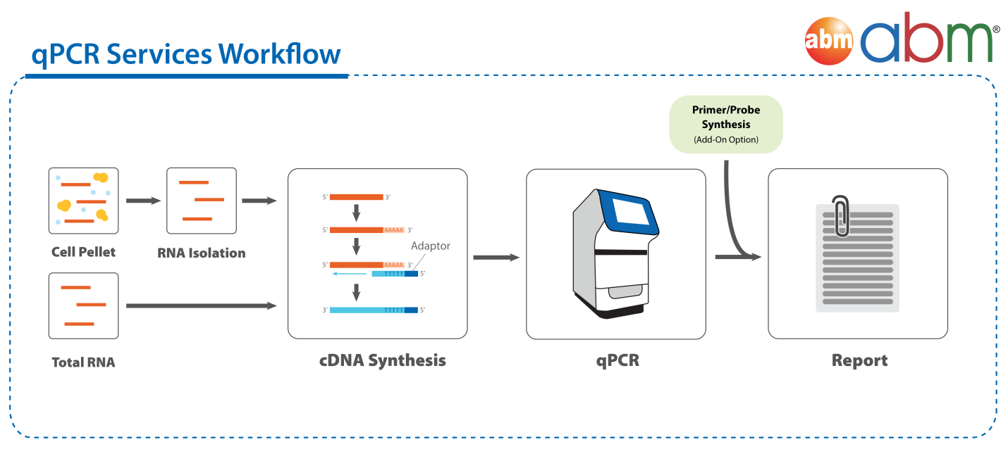

**5. Testimonial:**

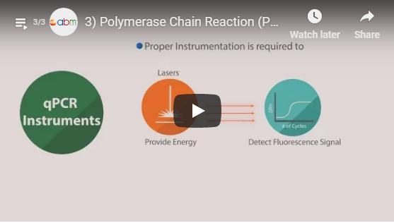

**Video:** Polymerase Chain Reaction (PCR) - Quantitative PCR (qPCR)

"**abm** has always been very helpful with technical assistance in any of our questions and concerns. I also consider the price for the services provided as very competitive, as other companies charge a multiple of **abm**'s price.**"** Dr. Cameron Moshfegh, ETH Zurich

**Additional Resources:**

qPCR Knowledge Base

**6. Core Services:**

|  |  |  |  |
| --- | --- | --- | --- |
| **SERVICE** | **UNIT** | **CAT. NO.** | **UNIT PRICE** |
| qPCR Service* | 1 Sample (triplicate)# | C533 | $25.00 |

**Add-On Services:**

|  |  |  |  |
| --- | --- | --- | --- |
| **SERVICE** | **UNIT** | **CAT. NO.** | **UNIT PRICE** |
| RNA Isolation | 1 Sample | C203 | $95.00 |
| cDNA Synthesis | 1 Sample | C204 | $75.00 |

For Primer or Probe synthesis services, please inquire with technical@abmgood.com.

* Pricing is valid for singleplex qPCR reactions with customer supplied primers/probes only. For multiplex reactions, please inquire prior to sample submission.

# Pricing is valid for quantification of one gene. Triplicate runs included to increase data reliability, i.e. customer will receive 3 Ct values per sample.



**7. Service Details:**

**Delivery Format:**

Detailed report containing Ct values for each sample

**Sample Submission Guideline:**

|  |  |
| --- | --- |
| **Sample format** | **Details** |
| Total RNA | * RNA isolated from >1 million cells supplied in 1 ml TRIzol solution, please ship on dry ice |
| Cell Pellet | * Please prepare from >1 million mammalian cells, please ship on dry ice |
| cDNA | * 2ug of cDNA for each gene to be tested per sample |
| Primers/Probes | * 100 ul of primers/probes at 100uM per target gene |

**Disclaimers and Policies**

**abm** is not responsible for storage of any customer provided reagents (cell pellet, RNA, PCR product and primers/probes) after report delivery.

Our goal is always to deliver high-quality qPCR data to aid you in your research. However, qPCR experiments by nature do not always deliver equally robust results due to a variety of factors, such as the quality of samples submitted (low RNA content or high level of contaminates) or the efficacy of primer designs received. Therefore, full service charges will apply regardless of the final data obtained unless qPCR issue is instrument-related. We will make every effort to deliver reliable qPCR results.

**8. Related Products:**

a) qPCR MasterMixes:

Link: [qPCR-Mastermix-Plus.html]

b) Primer Design & Synthesis Service:

Link: [Primer-Design-Primer-Synthesis.html]

c) Probe Synthesis (FAM/BHQ1):

Link: [Probe-Design-Probe-Synthesis.html]

**9. Documents:**

qPCR Service - Sample Report

**10. FAQs:**

**What reporter dyes and quenchers do you accept for probe-based qPCR services?**

For a list of reporter dyes that we accept, please visit the Probe Design & Synthesis page at: <https://new.abmgood.com/Probe-Design-Probe-Synthesis.html>

If you would like to use other reporter dyes, please inquire with [technical@abmgood.com](mailto:technical@abmgood.com).

No limitations on the type of quenchers submitted.

**Do you offer multiplex qPCR services?**

In general, multiplex reactions require extensive testing to establish the optimal primer/probe concentration. Please contact us at [technical@abmgood.com](mailto:technical@abmgood.com) to evaluate your multiplex request and submit detailed information on the experimental conditions to follow, as well as the target gene and primer/probe information.

**11. Citations:**

Coming Soon